Fowey 08/01/21
Morning lessons are expected to begin at 9.00 AM and finish at 12.00 PM. Please ensure children have a snack and light exercise between lessons 2 and 3. Afternoon lessons are expected to begin at 1.00 PM and finish at 3.00 PM. For the benefit of children’s health and well-being, we strongly encourage all children to exercise regularly.
If your child is unwell and unable to complete the learning tasks, you must notify the school and give details by emailing secretary@st-neot.cornwall.sch.uk by 9.30 AM.
Lesson 1  30 minutes | Lesson 2  1 hour | Lesson 3  1 hour | Lunch and break | Lesson 4  1 hour | Lesson 5  30 minutes
SPAG | English | Maths |  | PE | Reading

Lesson 1:SPAG
Learning Objective: WALT: recognise relative clauses
Resources: Relative Clauses document
Open the ‘Relative Clauses’ document. Read the questions and complete your answers. You can either print the document, complete the work and scan or photograph it to return. Or you can insert shapes and text boxes onto the document and return your work that way.

Lesson 2: English
Learning Objective: WALT: research definitions of words.
Resources: Volcano definitions and labelling pdf, volcano cross-section model pdf
Open the ‘Volcano definition and labelling’ file, look at the vocabulary at the bottom of the page. Use a physical and online dictionary to find definitions and copy them down. Then add the labels to the diagram to identify the different parts of a volcano. Afterwards, print the ‘Volcano cross-section model’ file, cut out the different parts, fold and stick it together. Can you name the different parts of the model?
If you cannot print the files, try to draw the diagrams on to paper and make your own.

Lesson 3: Maths
Learning Objective: WALT: multiply amounts of money.
Resources: Multiplying money 1 and 2 pdfs
You are going to recap compact multiplication with decimals numbers today. The questions are already laid out in the compact method. There are two sheets, please start on sheet 1. After you have completed eight questions and feel confident, you may move to sheet 2. If after eight questions you still find it tricky, please stay on sheet 1.
Sheet 1 example: Sheet 2 example:
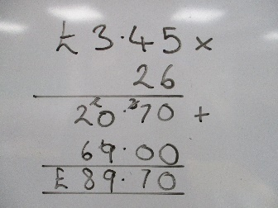
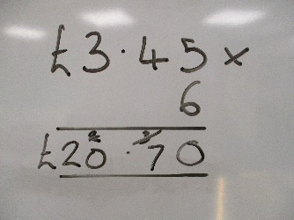
Don’t forget to add the zero!
Please ensure all tasks from morning lessons are submitted to Fowey@st-neot.cornwall.sch.uk by 1.00 PM at the latest.
Lesson 4: PE
Learning Objective: Improve our yoga understanding
Resources:
Go to the YouTube video Yoga for Focus | Kids Yoga Class with Yoga Ed. - YouTube and enjoy another beginner’s yoga session. Please note, it may be suitable to adjust the parental control to ensure no inappropriate adverts are shown. It would be great to see any photos of your yoga positions.

Lesson 5: Reading and times tables
Learning Objective: Vocabulary focus
Resources: The case of the silver snake pdf
Open the pdf file ‘The Case of the Silver Snake’. Answer the five VIPERS focus questions, make sure you reread the text to find answers if you need to. Check your responses against the answers on the last page.
Practise you times tables by logging onto TTRockstars.
Please ensure all tasks from afternoon lessons are submitted to Fowey@st-neot.cornwall.sch.uk by 3.30 PM at the latest.
Spellings for: 14/01/2021
Year 5 | Year 6
afterwards  immediately  earlier  eventually  previously  finally  recently  yesterday  tomorrow  whilst | accompany  accommodate  access  accuse  accost  accrue  accuracy  accomplish  accumulate  accentuate
X 25 | X 25

